**Joy For Kids Universal Donation and Shopping Cart System Proposed Project**



**IT111 Group 2 Members:**

**Lois Anne Logronio**

**Katharyn Alexandre Mayo**

**Renon Dadulla**

**Table of Contents:**

1. **Project Description........................................................................................3**

**1.1Client name…………………………………………………………...…3**

**1.2Background of the client…………………………………..……………3**

**1.3Organizational chart of the client……………………………………...3**

**1.4Stakeholders in the project from the client side…….……………...…3**

**2. Project Purpose/Objectives…………………………………….………………3**

**2.1Short Term Objectives………………………………….………………3**

**2.2Long Term Objectives…………………………………...…………..…3**

**3. Success Factors……………………………………………………………..…..4**

**3.1Short Term success factors………………………………………..……4**

**3.2Long Term success factors……………………………………………..4**

**4. Project Scope……………………………………..……………………….……4**

**4.1Business Requirements…………………..…………………………..…4  
     4.2Vision of the Solution…………………..……………………..……..…4  
         4.3Vision Statement …………………..……………………………….…..4  
         4.4Major Features…………………..………………………………….…..5  
         4.5Assumptions and Dependencies…………………..……………………5  
     4.6Business Context…………………..…………………………………….5  
         4.7Stakeholder's Profiles…………………..………………………………5**

**Project Description**

**Client name:** Katherine Kaye D. Mayo

**Background of Client:**

* Born January 5, 1964
* Studied in Ateneo: computer School Makati
* A former editor at the American Chamber
* Created 4 business until the end of 2014: Journeys and More Global Tours (2008), Icloud monster: Web services (2014), Travell Mall (2014), and JFK-Joy for Kids Universal Foundation (2014)

**Organizational chart of the client**

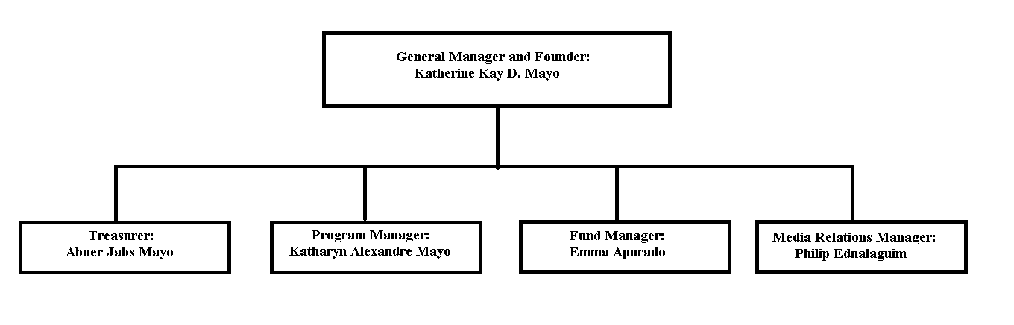

**Stakeholders in the project from the client side**

* General Manager and Founder: Katherine Kaye D. Mayo
* Treasurer: Abner Jabs Mayo
* Program Manager: Katharyn Alexandre D. Mayo
* Funds manager: Emma Apurado
* Media Relations Manager: Philip Ednalaguim

**Project Purpose/Objectives**

**Short Term Objectives**

* To create a system that will satisfy the clients need
* To be able to adapt from the new framework
* To convert the existing website from Wordpress framework to Yii framework
* To add photos and description of the company to the site

**Long Term Objectives**

* To reduce work load of the employees of JFKUniversal who are handling the online transaction
* To provide a more user friendly donation and shopping cart system
* To design a system that will be less time consuming for the clients and employees of JFKUniversal as well

**Success Factors**

**Short Term success factors**

* To create a website before the company opened
* To helped children who are in need for the 1st experience

**Long Term success factors**

* To create a system and website for clients all around the world to see
* To help people who are in need through a system still with a personal experience

**Project Scope**

**Business Background:**  
JFK has been created to the thought of helping the people who are in need which does not automatically mean that we are only helping the people who are poor. We provide services to help all kinds of people when it comes to children to youngsters to old people. We try to help them in different ways, such as spending time with them or helping them financially but our main purpose is to be with them in person and not only send them things or money to make them happy.

**Business Opportunity:**  
The opportunity in this business is to help both sides of the company. To make the people who need us happy and to gain profit from it and be proud of the job that was done by helping the need.

**The owner's needs:**  
To create a website and system for the people around the world to see.This is not just for the Filipino people who are willing to help but world-wide as well.  
One of the owners needs is to create a system where the people can donate funds for the foundation which will be mostly for the people in need and a percentage will be going to the foundation company itself.  
a second need is a shopping cart, which means, there are products and items for sale on the website to buy why supports our foundation and or charity or can give them as well to people in need.

### **Vision of the Solution**

#### **Vision Statement**

 The team envisions itself to be able to meet all the client's expectations and needs by applying all the knowledge and learning gathered from the previous subjects and internship.

#### **Major Features**

* Shopping Cart Module- The customer can buy goods and products through online
* Donation  Module- The customer can donate money through online
* Customer Support- The customer can message its concern to the admin of JFK

#### **Assumptions and Dependencies**

* The JFKUniversal assumes that the project will be able to come up with the best decision whenever there are more than one solution that is available and there are inconsistencies on the adopted solution
* The JFKUniversal assumes that the project will be able to meet its deadline by following the scheduled task
* Depending on the client's needs, some features may be change or modified
* Depending on the client's satisfaction, the project may be implemented

### **Business Context**

**Stakeholder's Profiles**

* General Manager and Founder: Katherine Kaye D. Mayo

            - Studied in Ateneo: computer School Makati

            - A former editor at the American Chamber

            - Created 4 business until the end of 2014: Journeys and More Global Tours (2008), Icloud monster: Web services (2014), Travell Mall (2014), and JFK-Joy for Kids Universal Foundation (2014)

* Program Manager: Katharyn D. Mayo

            - Currently studying in Asia Pacific College

            - Grew up in Vienna Autria (2002-2008)  
            - Has a sister in Ateneo (studying Environmental Science)  
            - Studied high school in: Colegio san Agustin Makati